Queen City Elder Care has been selected as the top home care agency in Cincinnati and surrounding areas every year since 2016. This distinction is based on third-party verified client reviews.



Queen City Elder Care Recognized as the Top Home Care Agency and Dementia Care in Ohio 2025
Queen City Elder Care has been named Ohio’s Top Home Care and Dementia Care Agency for 2025, honoring their exceptional, compassionate senior care services in Cincinnati.

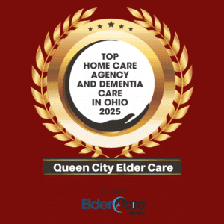

Elder Home Care Services for the Cincinnati, OH area:
- In-Home Alzheimer’s & Dementia Care
- 24-Hour Home Care
- Personal Care Services
- In-Home Companion Care
- In-Home Respite Care
- Senior Home Care

Recent Family Review from Daughter


Jacqueline Eliasen

5 months ago
I had a positive experience with Queen City Elder Care several years ago when my mother was very ill. This summer, when my father suddenly became gravely ill and needed help recovering, once again I contacted Sallie. She jumped in and assembled a team in just a few days in order to provide the support we needed. Her wonderful, loving team of caregivers has been a godsend at an extremely challenging time for our family.



